TECHNICAL DATA SHEET
ENG-AU-BLA-180CB
SIGNATURE AUSTRALIAN RANGE: BLACKBUTT CHARACTER SATIN

PRODUCT SPECIFICATIONS
PRODUCT RANGE | SIGNATURE AUSTALIAN RANGE | 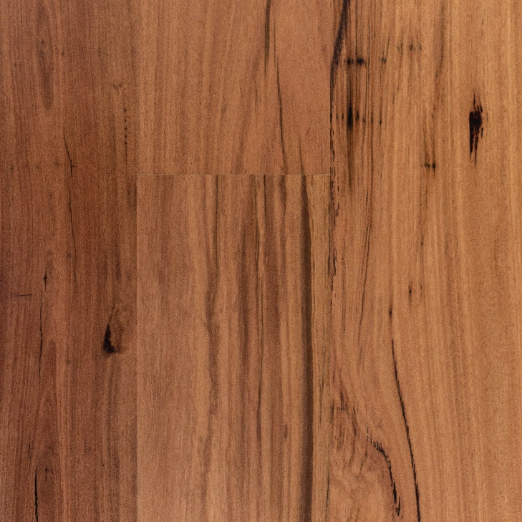  The photograph used in this sheet is intended as an illustration. It does not provide any indication of grading. Colours will vary between batches in stock.
COLOUR | BLACKBUTT
PRODUCT CODE | ENG-AU-BLA-180CB
CONSTRUCTION | MULTI-LAYERED ENGINEERED
BACKING | EUCALYPTUS PLYWOOD
GRADE | CHARACTER
PATTERN | 1 STRIP
BOX SIZE | VARIES WITH BATCH
EDGE | BEVEL
PROFILE | TONGUE AND GROOVE
FINISH | LACQUER
TOP LAYER | 3mm BLACKBUTT LAMELLA
THICKNESS | 14mm
WIDTH (mm) | 180
LENGTH | 1900mm (Product contains split lengths, with up to 25% shorter boards. These may be half or 1/3 lengths)

INSTALLATION METHODS
DIRECT STICK | YES
FLOATING ON UNDERLAY | YES
OVER UNDERFLOOR HEATING | YES WITH LIMITATIONS

AUSTRALIAN STANDARDS
ACOUSTIC RATING | DEPENDENT ON UNDERLAY
SLIP RATING  AS 4586-2013 | P2
FORMELDELHYDE RATING | E1
CRITICAL HEAT FLUX (CHF) MEAN  AS/ISO 9239.1-2003 | 3.2 kW/m²
JANKA HARDNESS RATING | 9.1kN
WARRANTY
RESIDENTIAL | LIFETIME STRUCTURAL
COMMERCIAL | 10 YEARS STRUCTURAL

